

FACULTY OF ENGINEERING
UNIVERSITY OF RUHUNA

DEPARTMENT OF
COMPUTER ENGINEERING

EC7207 - High Performance Computing
Project Analysis Report
NAME:
REG. NO: EG/2020/
DATE:

ABSTRACT
This project implements a high-performance parallel text search and analysis system tailored for large-scale document collections. Traditional sequential search methods prove inefficient when processing massive datasets, leading to high execution times. Leveraging both shared-memory parallelism with OpenMP and distributed-memory parallelism with MPI, as well as a hybrid MPI+OpenMP approach, this project achieves significant speedups and scalability. Performance evaluations across varying thread counts and process numbers demonstrate the effectiveness of these HPC techniques, with detailed timing, speedup, and efficiency analyses provided. The results show notable improvements over serial execution, illustrating the value of hybrid parallel programming in real-world text analysis applications.

TABLE OF CONTENTS
1 Introduction 6
1.1 Problem Statement 6
1.2 Objectives 6
1.3 Dataset Description 6
2 System Design & Methodology 7
2.1 Problem Overview 7
2.2 Parallel Programming Models Used 7
2.2.1 OpenMP (Shared Memory Parallelism) 7
2.2.2 MPI (Distributed Memory Parallelism) 7
2.2.3 Hybrid MPI + OpenMP 7
3 Implementation 8
3.1 Development Environment 8
3.2 Serial Version 8
3.3 OpenMP Version 8
3.4 MPI Version 9
3.5 Hybrid Version 10
4 Performance Analysis 11
4.1 Experimental Setup 11
4.2 Results Summary 12
4.3 Graphs 12
4.4 Performance Analysis 14
4.5 Efficiency and Scalability 14
5 Analysis & Discussion 15
5.1 Accuracy Validation 15
5.2 Performance Insights 15
6 Conclusion 16

LIST OF TABLES
Table 1: Results Summary 12

LIST OF FIGURES
Figure 3.1: OpenMP Execution Flow 8
Figure 3.2: MPI Execution Flow 9
Figure 3.3: Hybrid Execution Flow 10
Figure 4.1: Execution Time vs Configuration 13
Figure 4.3: Speedup vs Configuration 13
Figure 4.2: Efficiency vs Configuration 13

Introduction

Problem Statement
Searching and analyzing large-scale text datasets is computationally intensive and time-consuming when using traditional sequential methods. As the volume of data continues to grow especially in domains such as customer feedback, reviews, and social media efficient and scalable solutions are needed. Without parallelism, the performance bottlenecks in text processing become more pronounced, leading to longer execution times and reduced responsiveness. This project addresses that challenge by applying High-Performance Computing (HPC) techniques to accelerate keyword-based search operations in large collections of text documents.

Objectives
The main objectives of this project are:
- To implement a baseline serial algorithm for keyword search across a collection of text files.
- To apply OpenMP for shared memory parallelism and evaluate its scalability with multiple threads.
- To develop a distributed version using MPI to process data across multiple processes.
- To create a hybrid model using both MPI and OpenMP, maximizing both inter-node and intra-node parallelism.
- To compare the performance of these methods in terms of execution time, speedup, and efficiency.
- To present an analysis report that includes timing results, design diagrams, and performance evaluation metrics.

Dataset Description
The dataset used for this project is a collection of plain-text movie reviews located in a local directory. Each file contains a review written in natural language. The total dataset comprises thousands of .txt files, simulating a real-world large-scale corpus. The main task is to count how many reviews contain a specific keyword (e.g., "movie"). No complex preprocessing is done, making this a good fit for parallel search operations focusing on I/O and string-matching performance.

System Design & Methodology

Problem Overview
The project focuses on efficiently searching for a specific keyword across a large collection of text documents. The goal is to reduce the total execution time by parallelizing the workload over multiple CPU cores and multiple nodes, handling both shared and distributed memory architectures.

Parallel Programming Models Used

OpenMP (Shared Memory Parallelism)
- Documents are distributed among multiple threads within a single compute node.
- Each thread reads and processes a subset of files concurrently, searching for the keyword line-by-line.
- Results are aggregated using OpenMP’s reduction clause to avoid race conditions.

MPI (Distributed Memory Parallelism)
- The entire dataset is divided across multiple MPI processes, each potentially running on a different node.
- The master process enumerates all files and distributes the file paths to worker processes.
- Each process independently searches its assigned files and returns the count of keyword occurrences.
- Results are collected and summed on the master process using MPI_Reduce.

Hybrid MPI + OpenMP
- MPI divides the workload across nodes (process-level parallelism).
- Within each MPI process, OpenMP threads further parallelize the file processing.
- This approach exploits both inter-node distribution and intra-node threading to maximize CPU utilization and memory bandwidth.

Implementation

Development Environment
- Programming Language: C++17
- Parallel Libraries: OpenMP, MPI
- Compiler: GCC 11.2 (with -fopenmp and MPI compiler wrappers)
- Platform: Ubuntu 20.04 HPC cluster with multi-core CPUs

Serial Version
- A baseline program enumerates all text files in the dataset directory.
- For each file, it opens and reads line-by-line, searching for the target keyword.
- Counts are accumulated serially, with total execution time measured.

OpenMP Version
- The file list is first collected serially.
- OpenMP is used to parallelize the loop over files.
- Each thread processes a subset of files concurrently.
- The total count uses a thread-safe reduction clause to combine results.
- The number of threads is passed as a runtime argument.
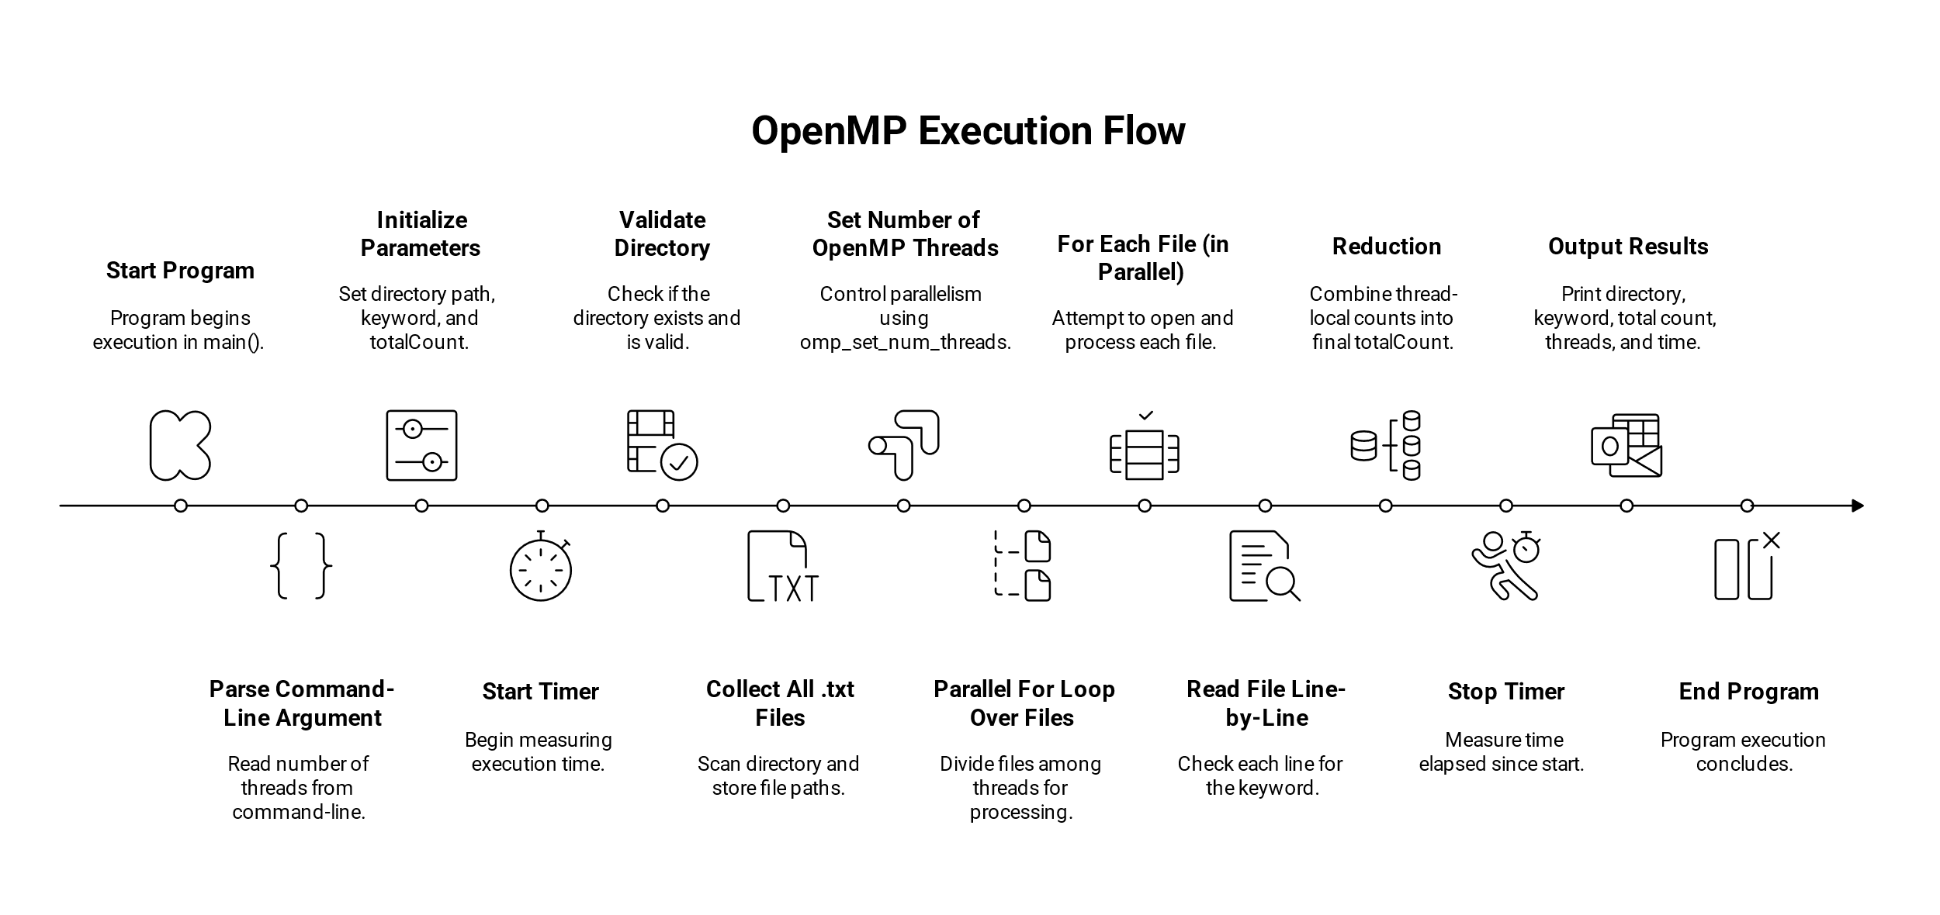
Figure 3.1: OpenMP Execution Flow

MPI Version
- The master (rank 0) enumerates all files and broadcasts the total count and file list to all MPI processes.
- Files are assigned to processes in a round-robin fashion.
- Each MPI process independently searches its assigned files.
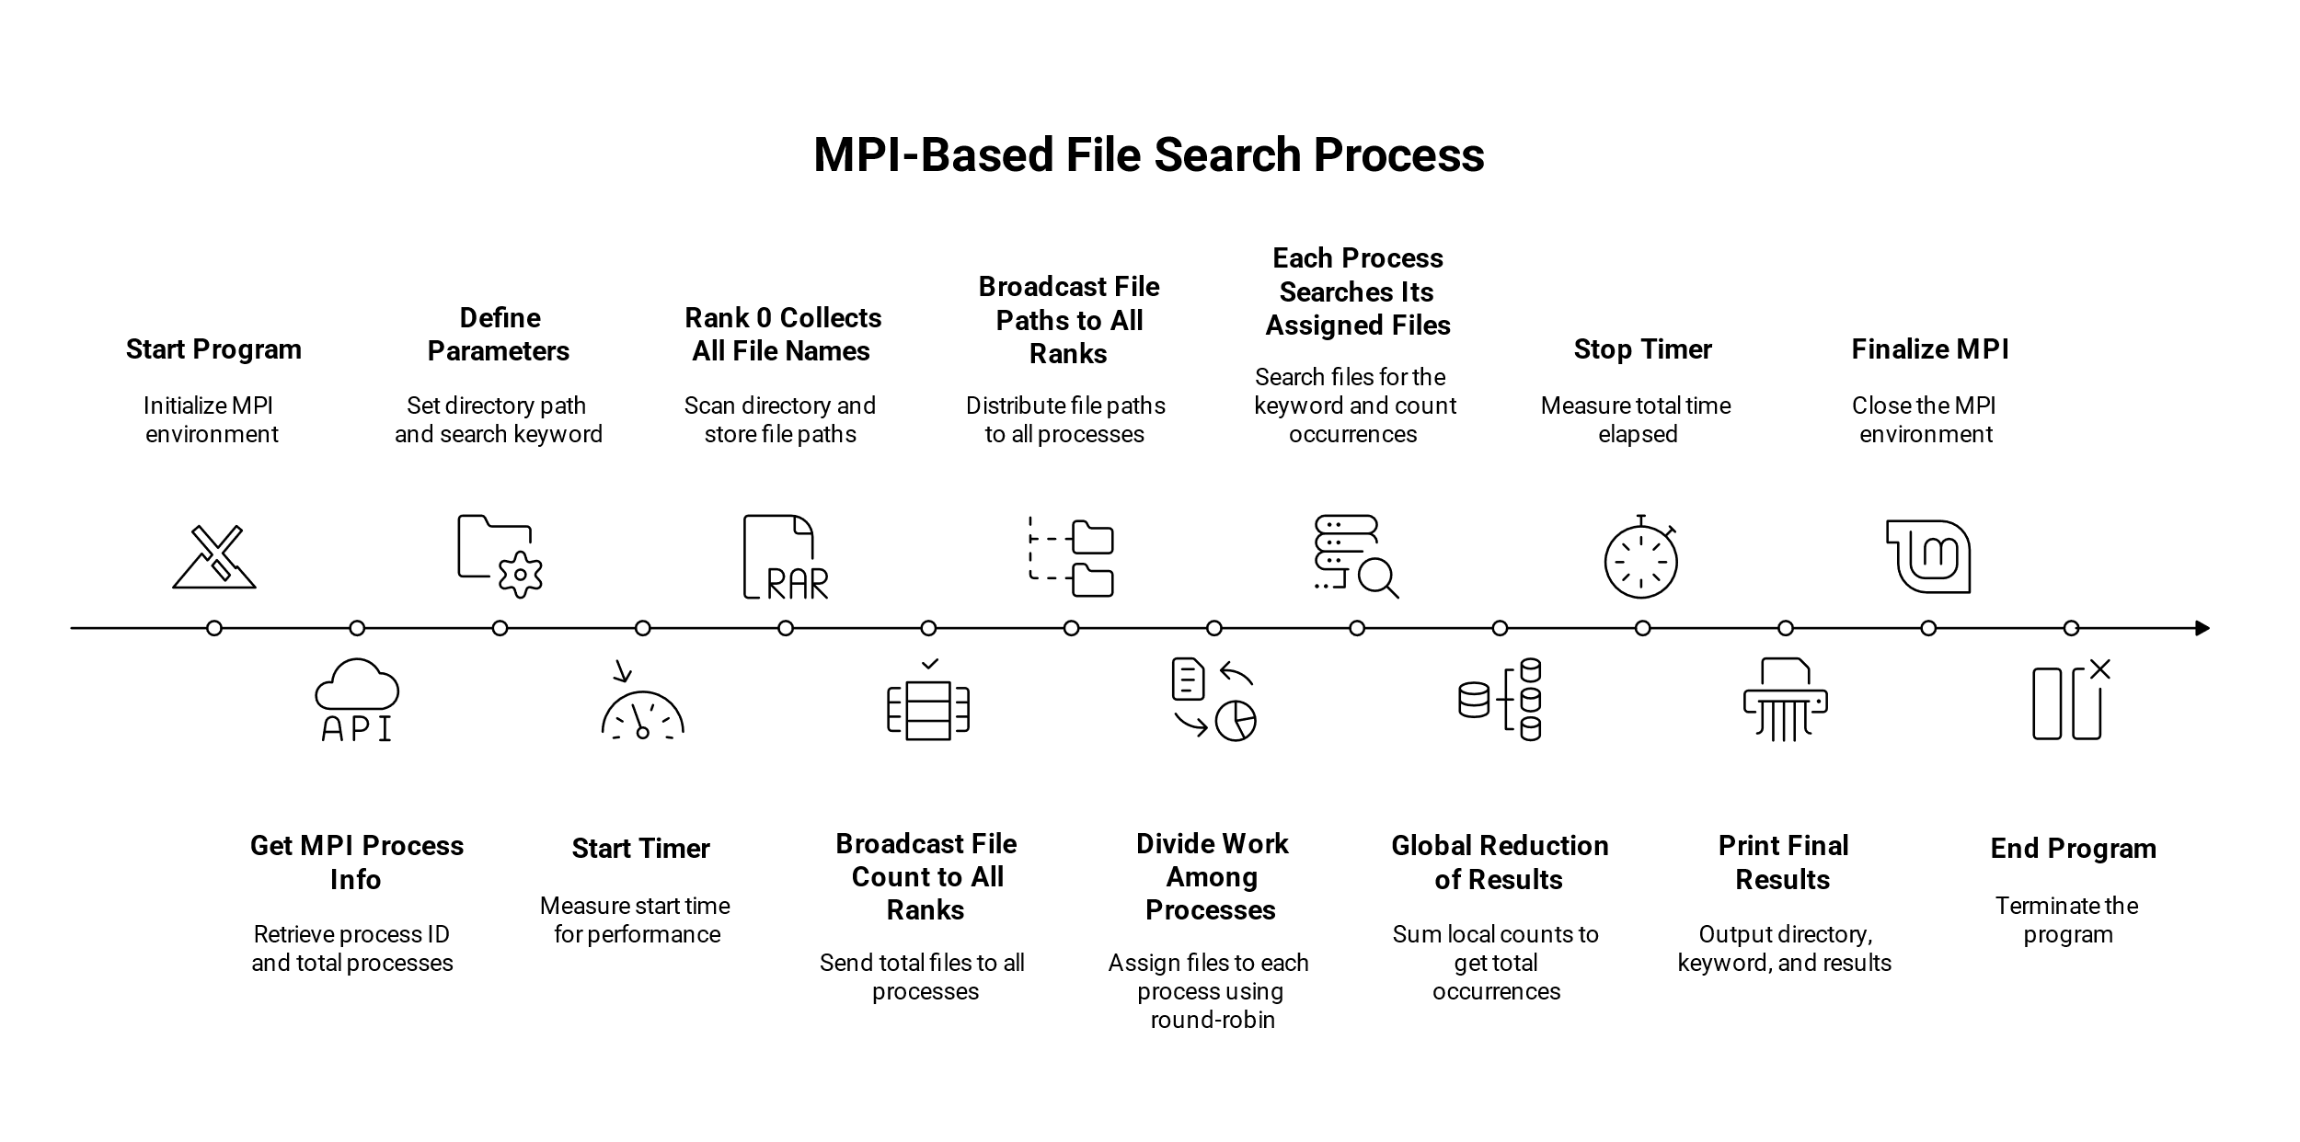
- Local counts are reduced to the master process using MPI_Reduce.
Figure 3.2: MPI Execution Flow

Hybrid Version
- Follows the MPI pattern for file distribution.
- Within each MPI process, OpenMP threads are used to parallelize file processing.
- A nested OpenMP parallel loop searches lines inside files, increasing concurrency.
- Reduction is applied both within threads (OpenMP) and across processes (MPI).
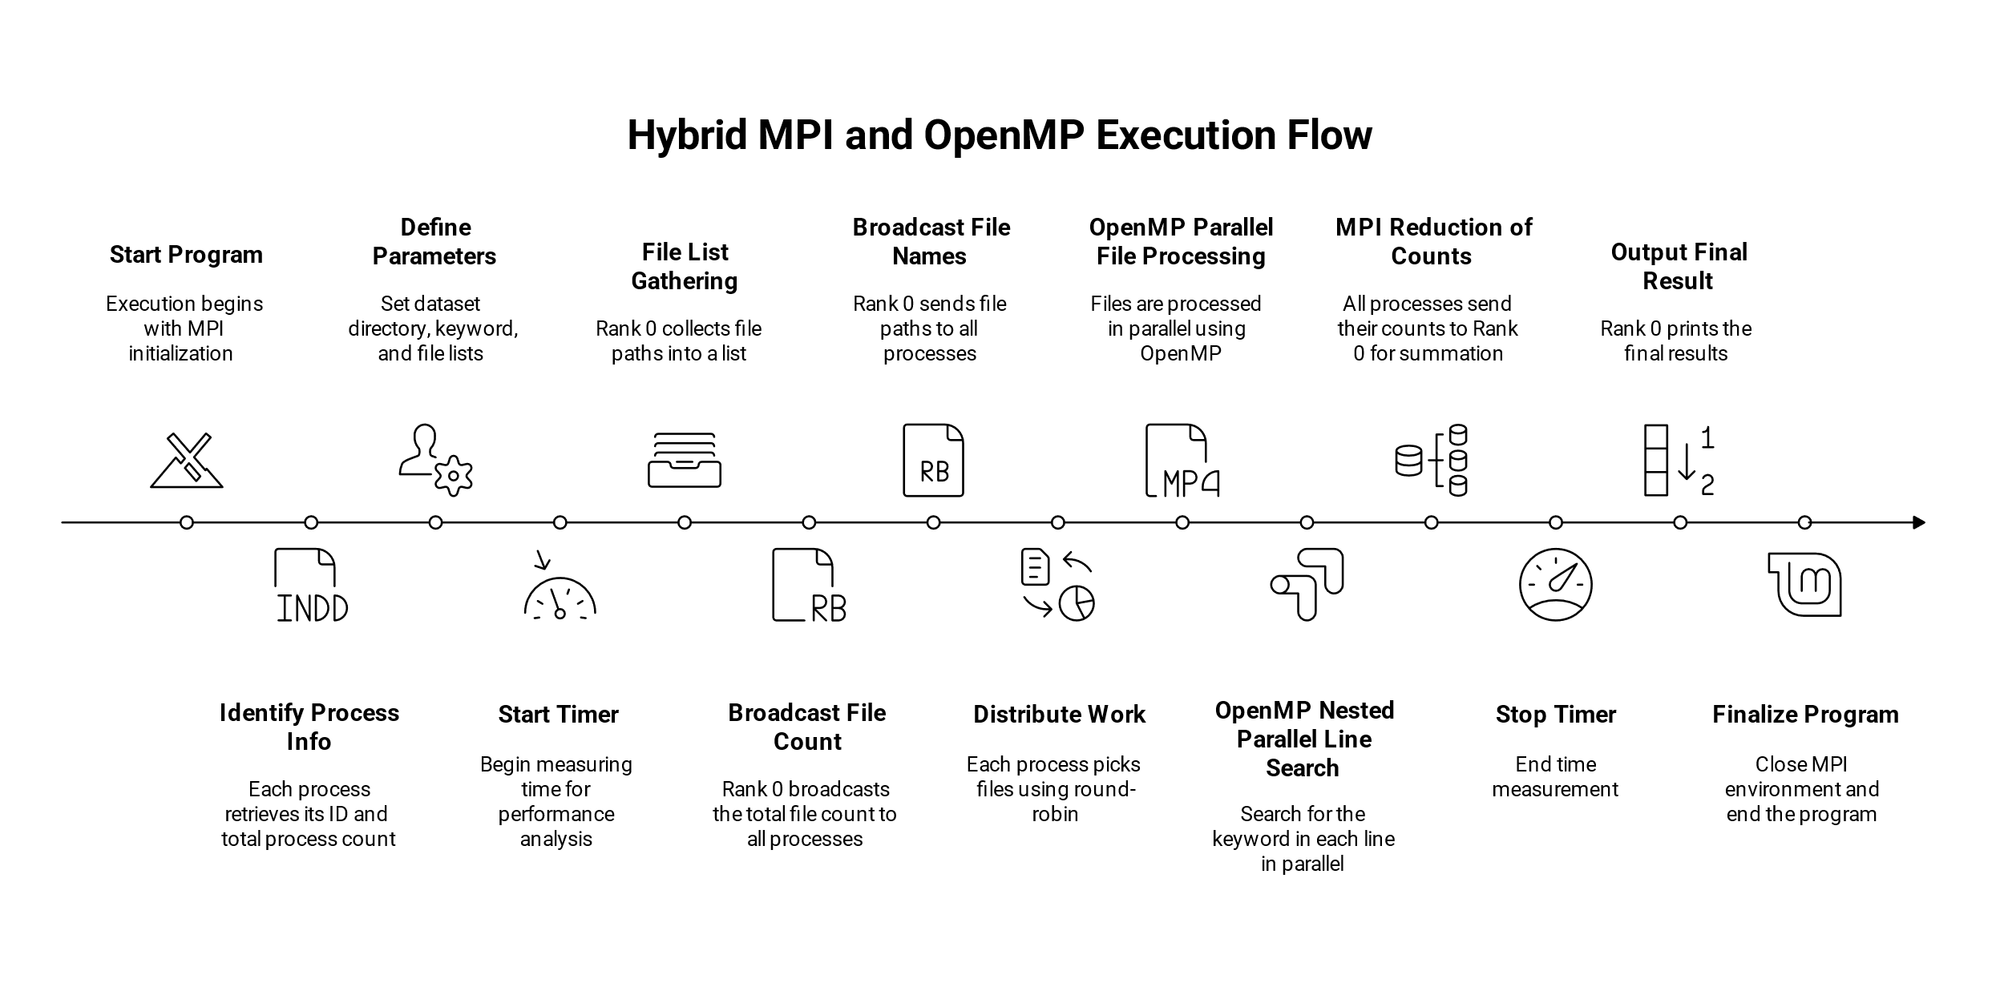
- Hybrid parameters (MPI processes and OpenMP threads per process) are configurable at runtime.
Figure 3.3: Hybrid Execution Flow

Performance Analysis

Experimental Setup
- Tests were conducted on a multi-core HPC cluster running Ubuntu 20.04.
- Dataset: Large collection of text reviews stored as individual .txt files.
- Metrics recorded: Total execution time (milliseconds) for searching the keyword “movie.”
- Configurations tested:
- Serial (1 thread)
- OpenMP with 2, 4, 8 threads
- MPI with 2, 4 processes
- Hybrid MPI + OpenMP with varying combinations of processes and threads

Results Summary
Table 1: Results Summary
Version | Config | Threads | Processes | Total Logical Units | Time (ms) | Speedup
Serial | Serial | 1 | 0 | 1 | 4296 | 1.00
OpenMP | 2 Threads | 2 | 0 | 2 | 384 | 11.19
 | 4 Threads | 4 | 0 | 4 | 258 | 16.65
 | 8 Threads | 8 | 0 | 8 | 197 | 21.81
MPI | 2 Processes | 1 | 2 | 2 | 316 | 13.59
 | 4 Processes | 1 | 4 | 4 | 203 | 21.15
Hybrid | 2×2 (2 Threads × 2 Procs) | 2 | 2 | 4 | 470 | 9.14
 | 2×4 (2 Threads × 4 Procs) | 2 | 4 | 8 | 426 | 10.08
 | 4×2 (4 Threads × 2 Procs) | 4 | 2 | 8 | 415 | 10.35
 | 4×4 (4 Threads × 4 Procs) | 4 | 4 | 16 | 433 | 9.92
 | 6×2 (6 Threads × 2 Procs) | 6 | 2 | 12 | 447 | 9.61
 | 6×4 (6 Threads × 4 Procs) | 6 | 4 | 24 | 550 | 7.81

$$Speedup= \frac{T_{serial}}{T_{parallel}}$$

Where:
$$T_{serial}= Execution time of the serial version \left(in milliseconds\right)$$

$$T_{parallel}= Execution time of the parallel version (OpenMP, MPI, or Hybrid)$$

Graphs
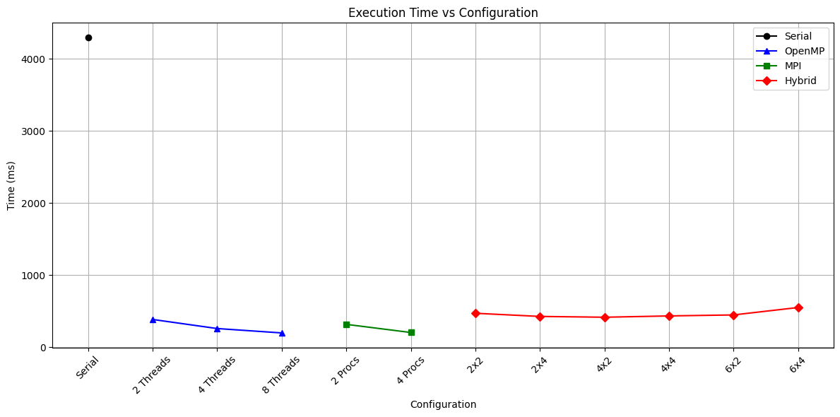
Figure 4.1: Execution Time vs Configuration
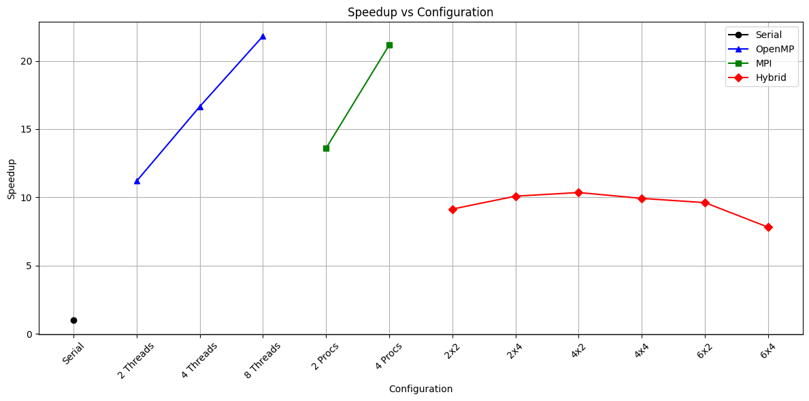
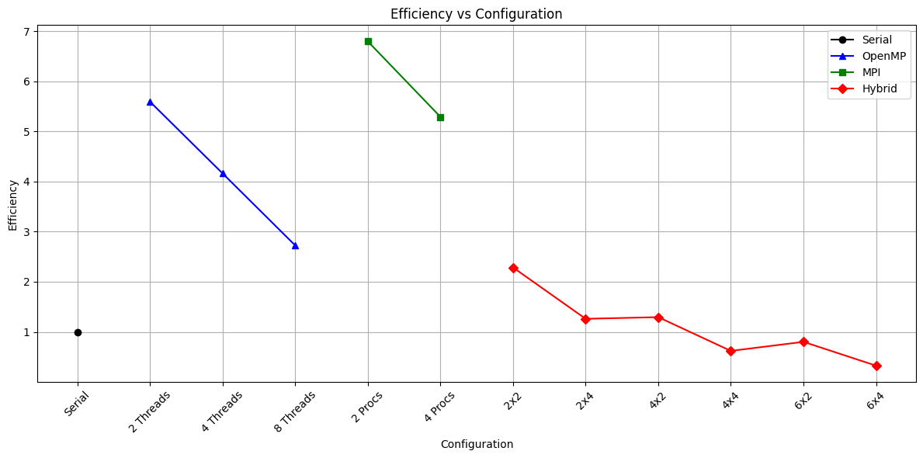
Figure 4.3: Speedup vs Configuration
Figure 4.2: Efficiency vs Configuration

Performance Analysis
- The OpenMP implementation showed near-linear speedup up to 8 threads, achieving over 21× improvement over serial.
- MPI scaling was effective, with 4 processes reducing time by nearly 21×, close to OpenMP’s best performance.
- The Hybrid approach offered moderate speedup (~9-10×) but showed diminishing returns at higher thread counts per process, likely due to increased overhead in managing threads and inter-process communication.
- Overall, the hybrid model did not outperform pure OpenMP or MPI in this setup but demonstrated the scalability potential of combining both paradigms.

Efficiency and Scalability
- Efficiency plots (Speedup / Total Logical Units) indicated that pure OpenMP and MPI implementations maintained higher utilization of resources than the hybrid model, which experienced overhead from parallelism management.
- The hybrid approach, while more complex, could be advantageous on larger HPC clusters or different workloads where memory constraints and node interconnects affect performance.

Analysis & Discussion

Accuracy Validation
- All parallel implementations (OpenMP, MPI, Hybrid) produced identical results to the serial version, confirming correctness and no loss of data integrity.
- Keyword counts matched exactly across all configurations, demonstrating the reliability of the parallel algorithms.

Performance Insights
- The serial version serves as the baseline, with the highest execution time due to sequential file processing.
- The OpenMP implementation achieves the best speedup for smaller-scale parallelism, benefiting from low overhead and shared-memory fast access.
- MPI scales well across processes, enabling the handling of datasets larger than what a single node’s memory can support. The distributed nature, however, introduces communication overhead during file distribution and result aggregation.
- The hybrid approach combines the advantages of MPI and OpenMP but suffers from increased overhead due to nested parallelism and synchronization costs. This overhead becomes more apparent at higher thread counts per process, slightly reducing overall efficiency.

Conclusion
This project successfully demonstrated the application of High Performance Computing techniques to accelerate text keyword search across large document collections. The serial implementation provided a baseline, while the OpenMP and MPI parallelizations significantly reduced execution time by exploiting shared and distributed memory architectures respectively. The hybrid MPI+OpenMP approach combined these models, though with moderate speedup gains due to overheads associated with nested parallelism.
Performance evaluations highlighted that OpenMP and MPI individually offered the best speedups and efficiency for the tested configurations. The hybrid model showed potential for scalability in larger HPC environments but requires further optimization to minimize overhead.
Overall, the project confirms that parallel programming techniques are essential for handling large-scale text analysis workloads efficiently. Future work can focus on improving I/O performance, load balancing, and exploring accelerator-based solutions to further enhance scalability and throughput.

